|  |  |  |  |
| --- | --- | --- | --- |
| BOILING POINT (INITIAL): | 94-98°C | SPECIFIC GRAVITY: | 0.9 typical at 25oC |
| SOLUBILITY IN WATER: | Partially soluble in water | pH: | Not applicable |
| VAPOR PRESSURE:  PERCENT VOLATILE: | Not determined | VAPOR DENSITY: | Not determined |
| VOC: | Not determined |
| COEFFICIENT OF WATER/OIL DISTRIBUTION: | Not determined | APPEARANCE/ODOR: | Milky liquid with a petroleum odor |
| FLASHPOINT: | -8°C | FLAMMABLE LIMITS: | LEL: 1.1% UEL: 6.7% |

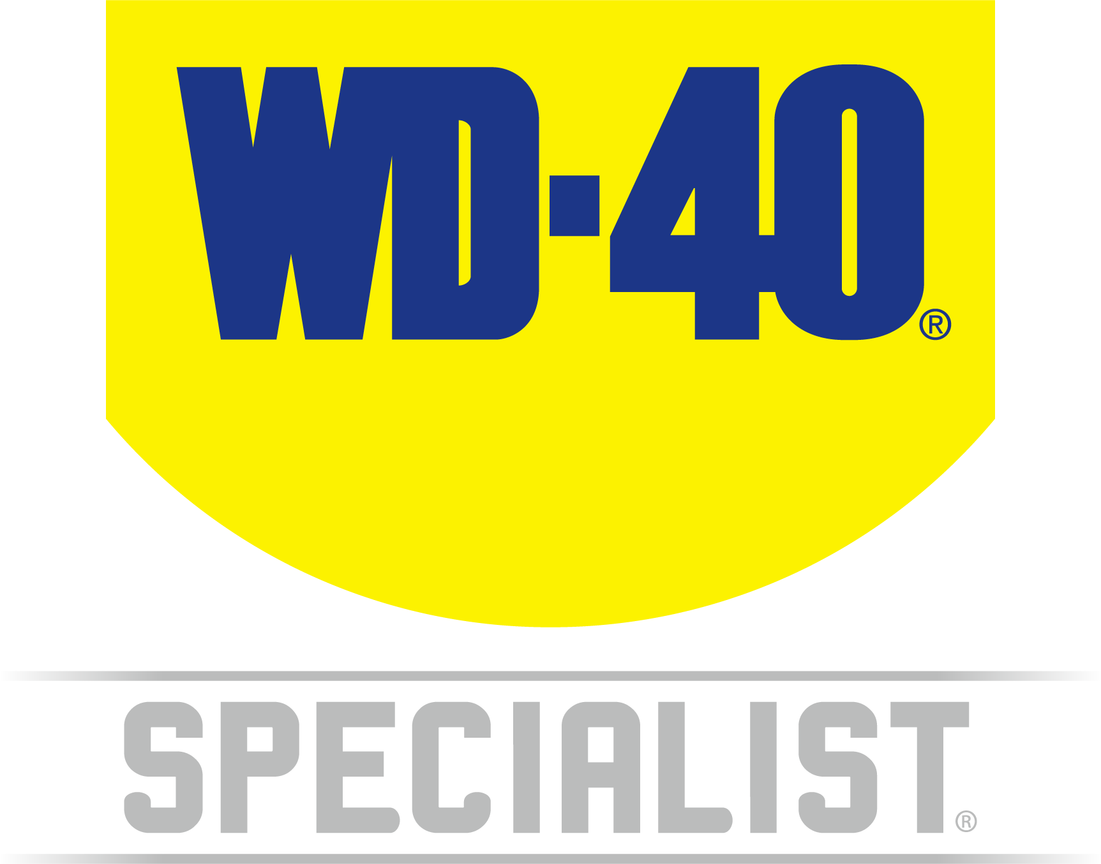

WD-40 Specialist®

Belt Dressing

**TECHNICAL DATA SHEET**

|  |  |  |
| --- | --- | --- |
| **Product Description** | | **PACKAGING** |
| WD-40 Specialist Belt Dressing penetrates the cord fibres to restore flexibility and pliability. It is formulated to extend belt life while providing better grip and traction for all types of old belts. It eliminates squeaking & slipping by restoring belts’ pliability & flexibility. It also extends belt life. | |  |
| **Applications** | **Features & Benefits** |
| * Timing Belts * Cogged Belts * Flat Belts * V Belts | * Formulated to extend old belt* life while providing better grip & traction for all types of belts * Eliminates squeaking & slipping * Restores belts pliability & flexibility   * It is designed for old belt. DO NOT use on new or good condition belt |
| **FLuid Properties** | | |

|  |
| --- |
| **Packaging Specifications** |
| |  |  |  |  |  |  |  |  |  |  |  |  |  |  |  |  |  |  |  | | --- | --- | --- | --- | --- | --- | --- | --- | --- | --- | --- | --- | --- | --- | --- | --- | --- | --- | --- | | **SKU Codes and Description** | | | **Individual Item (Consumer Unit)** | | | | | **Carton (Traded Unit)** | | | | | | **Pallet Information** | | | | | | **Case Codes** | **Unit Codes** | **Product Description** | **Dimensions (mm)** | | | **Cubic Volume (cm³)** | **Gross Weight (kg)** | **Dimensions (mm)** | | | **Cubic Volume (cm³)** | **Gross Weight (kg)** | **Units**  **Per**  **Carton** | **Consumer Units Per Pallet** | **Dimensions (mm)** | | | **Gross Weight (kg)** | | **Width** | **Depth** | **Height** | **Width** | **Depth** | **Height** | **Width** | **Depth** | **Height** | | 21128 | 21031 | WD-40 Specialist Belt Dressing 316g | 66 | 66 | 204 | 888.6 | 0.425 | 135 | 201 | 205 | 5562.6 | 2.615 | 6 | 1200 | 1165 | 1165 | 1175 | 557 | |
| **Directions** |
| SHAKE CAN WELL before EACH spray. Attach extension tube. With engine running, spray lightly on Inner working surface of belt near smallest or upmost pulley. Allow belt to run for several minutes to condition and cure dressing. Apply sparely, reapply as needed. |

|  |
| --- |
| **Hazard identification** |
| HAZARDOUS SUBSTANCE. DANGEROUS GOODS. According to the WHS Regulations and the ADG Code.  **DANGER! Extremely flammable aerosol. Pressurized container: may burst if heated. May be fatal if swallowed and enters airways. Causes skin irritation. May cause drowsiness or dizziness. Toxic to aquatic life with long lasting effects.** Keep away from heat, hot surfaces, sparks, open flames and other ignition sources. No smoking. Do not spray on an open flame or other ignition source. Do not pierce or burn, even after use. Avoid breathing mist or vapors. Wash thoroughly after handling. Use only outdoors or in a well-ventilated area. Avoid release to the environment. Wear protective gloves. If swallowed: Immediately call a POISON CENTER or doctor. DO NOT induce vomiting. If on skin, wash with plenty of soap and water. Take off contaminated clothing and wash it before reuse. If inhaled: Remove person to fresh air and keep comfortable for breathing. If discomfort persists, see a doctor. Additional information is listed in the safety data sheet. |
| **Storage** |
| Store in a cool, dry, well-ventilated locked up place, away from incompatible materials. Protect from physical damage. Do not store in direct sunlight, near open flames or above temperatures greater than 50°C |
| **Regulatory Information** |
| **Montreal Protocol (Ozone Depleting Substances):** None present. **The Stockholm Convention (Persistent Organic Pollutants):** None present. **The Rotterdam Convention (Prior Informed Consent):** Not applicable. **Basel Convention:** Not applicable. **International Convention for the Prevention of Pollution from Ships (MARPOL):** Not applicable. **Standard for the Uniform Scheduling of Medicines and Poisons (SUSMP):** Not applicable  **Australian Inventory of Chemical Substances:** All the components of this product are listed on the AICS inventory  **New Zealand Inventory:** All the ingredients comply with the HSNO regulations |
|  |



WD-40 Specialist®

Belt Dressing



**TECHNICAL DATA SHEET**

Level 2, 41 Rawson Street, Epping, NSW 2121 Australia  **Version: 1.0**

**wd40.com.au**